https://developer.servicenow.com/app.do#!/home
suhas-sudhakar.shirbavikar@atos.net
password
https://dev318910.service-now.com/now/platform-analytics-workspace/data-visualization-library

https://dev318910.service-now.com/navpage.do
admin
Jan30

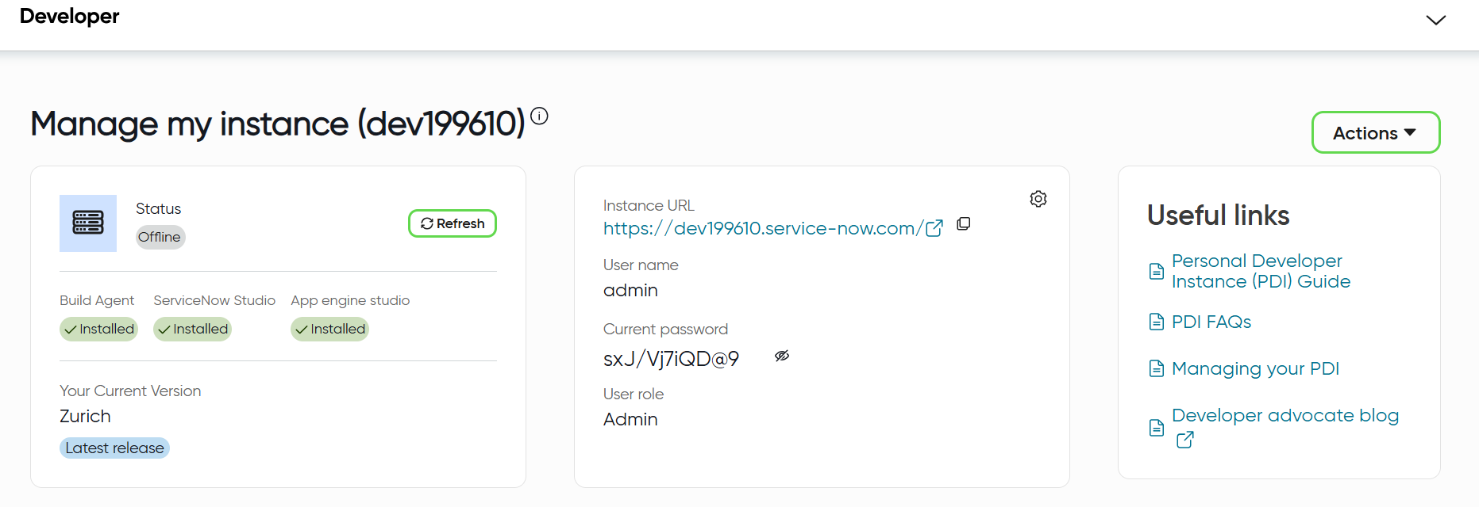
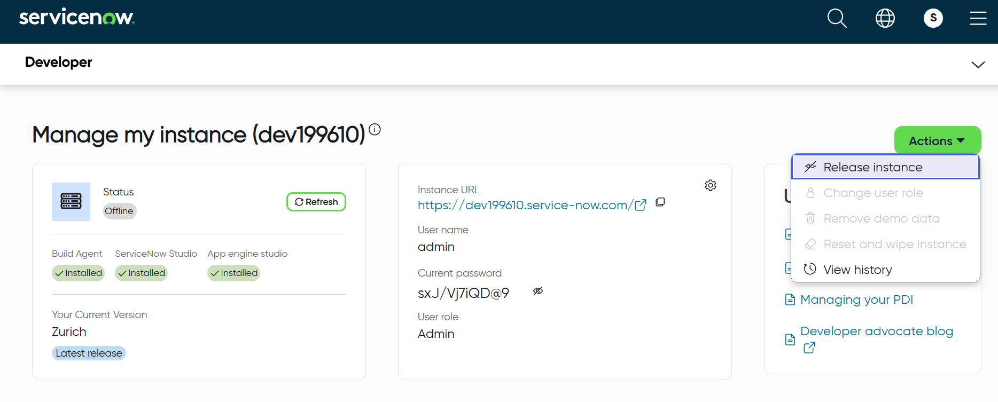
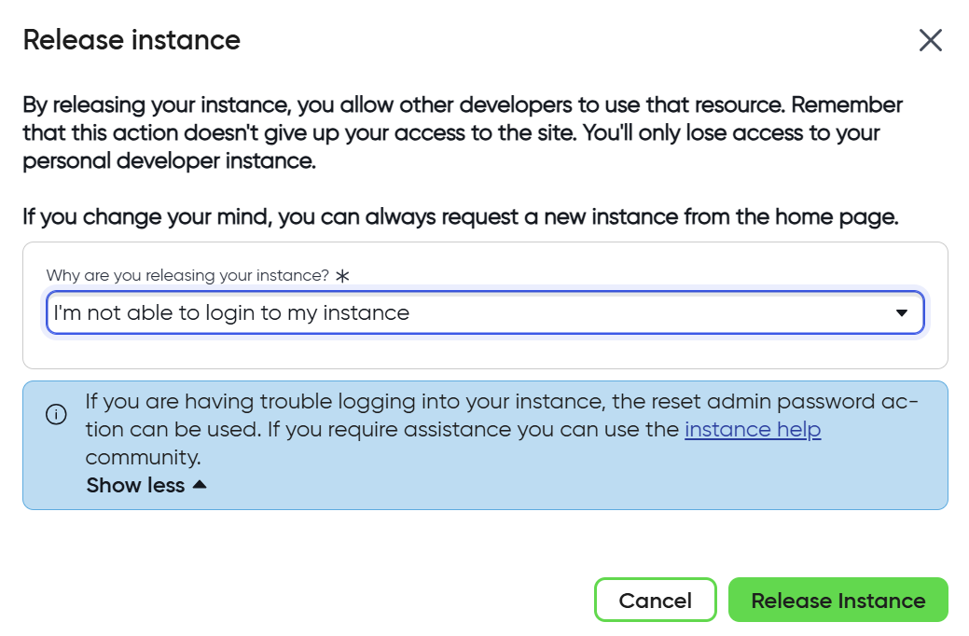
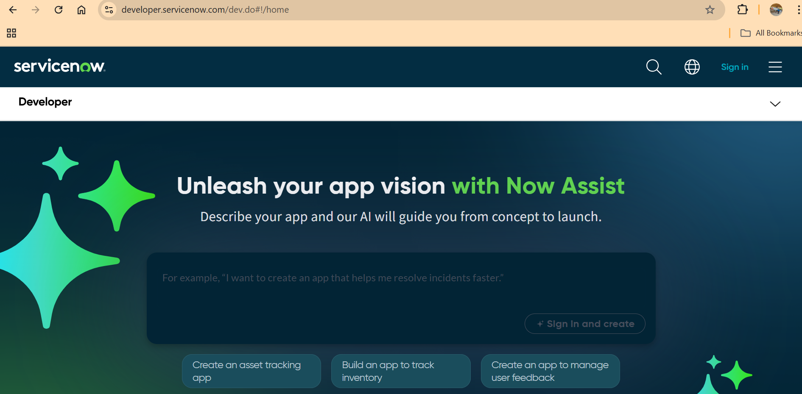

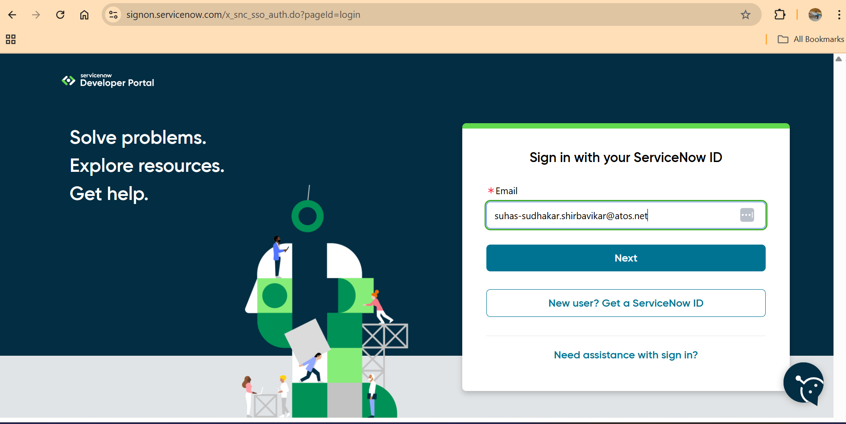
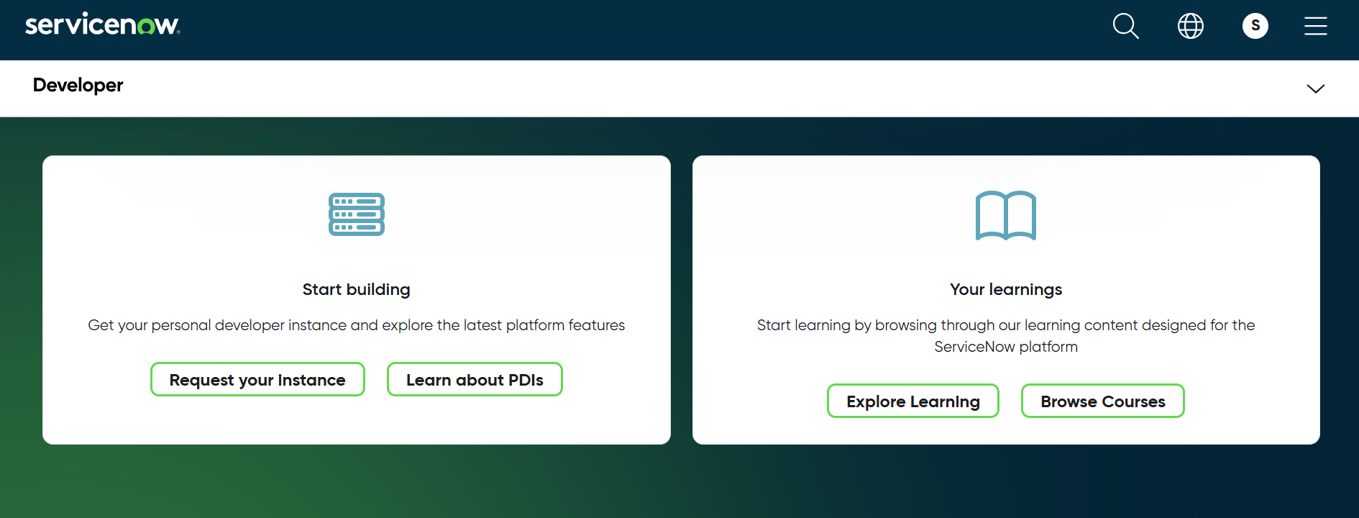
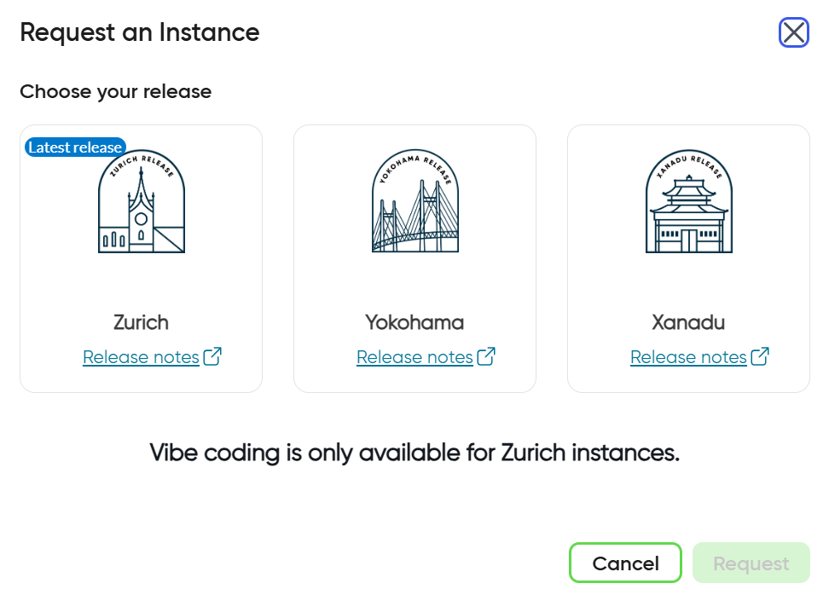
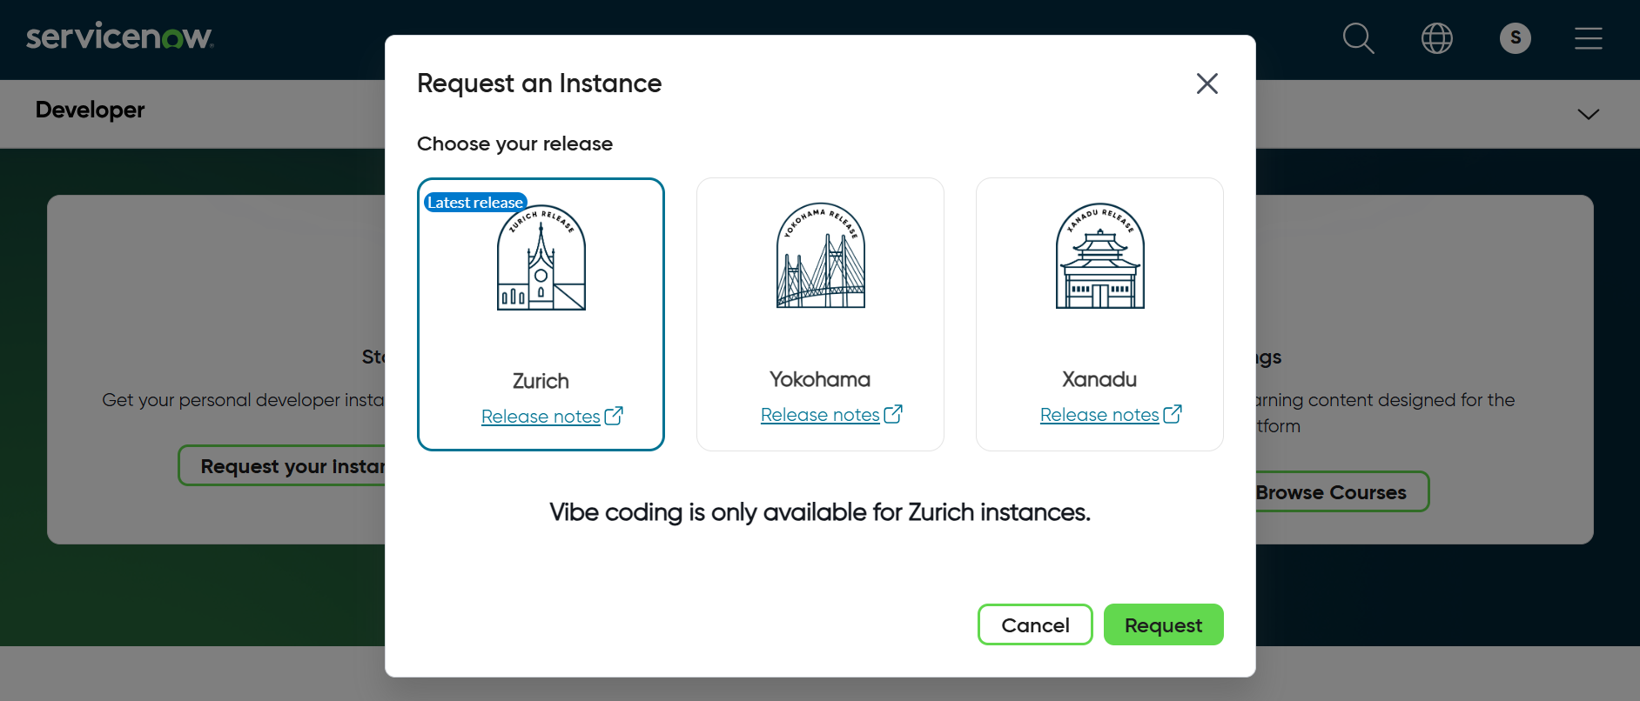
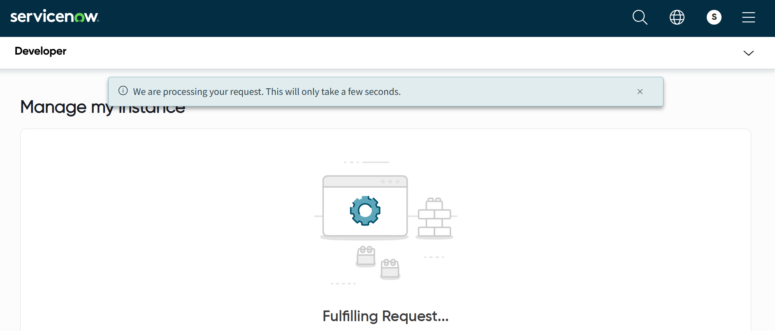

Some time may take 10 mins …
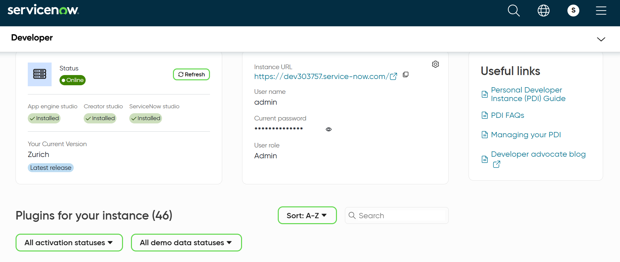

https://dev192887.service-now.com/login.do?user_name=admin&sys_action=sysverb_login&user_password=YPknd3N%24i%241O
admin
password
after login to instant …
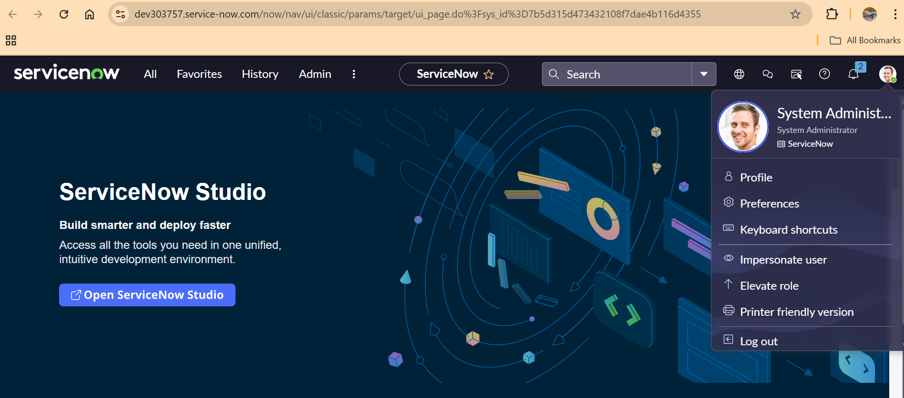
Click on Profile…
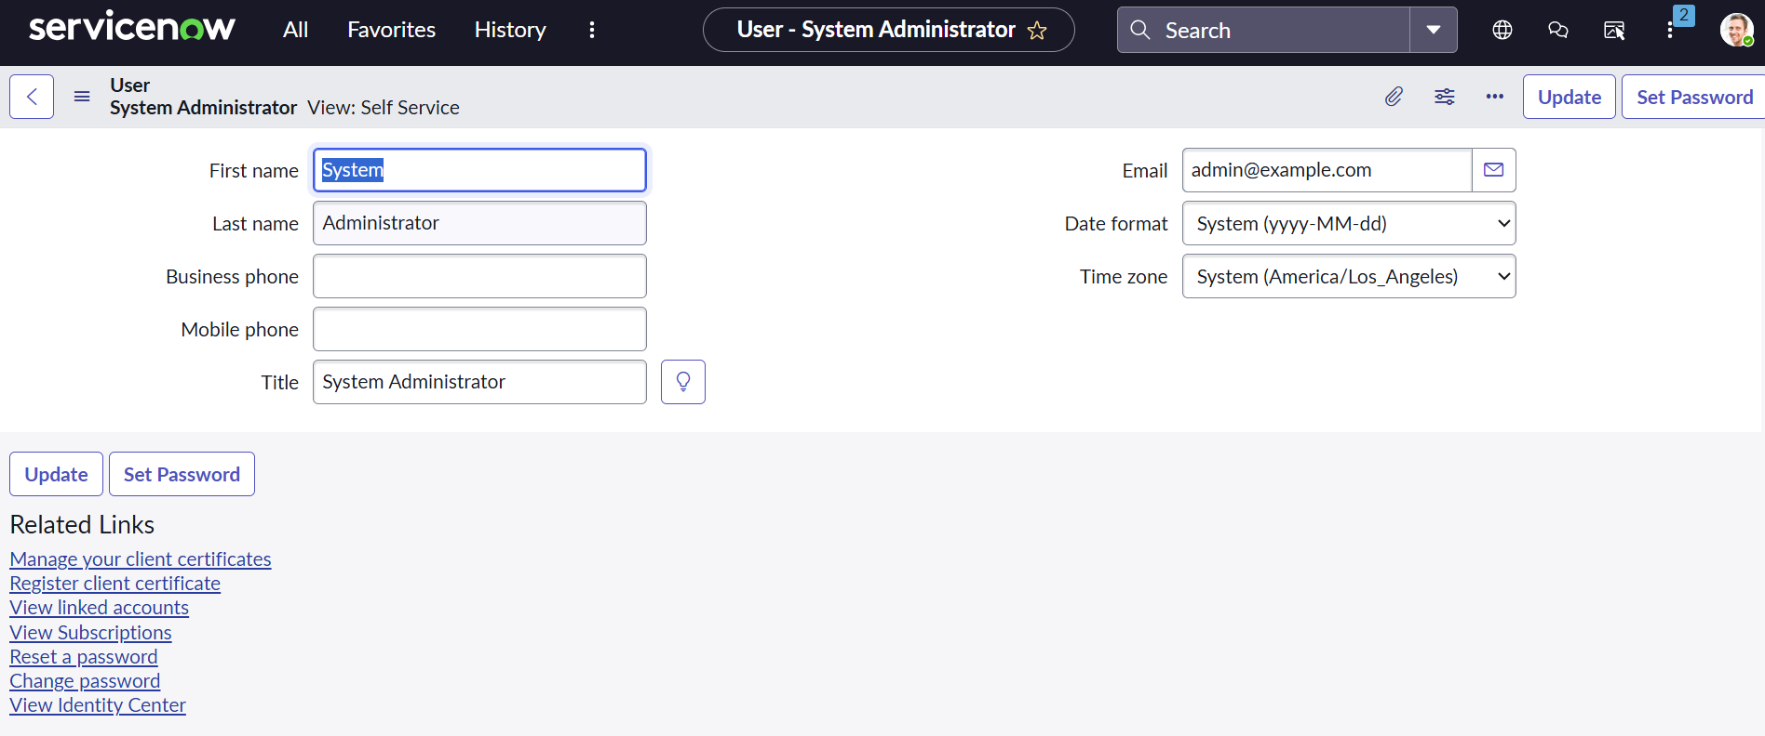
Click on Change password…

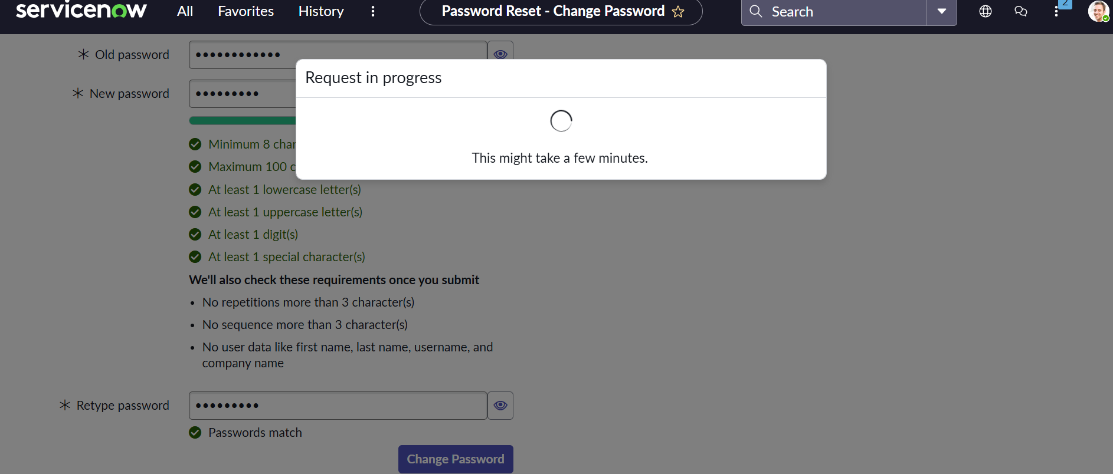
After that Click on Impersonate user….
